

# Word Focus

* 1. Force
  2. Push
  3. Pull
  4. Object
  5. Direction
  6. Motion
  7. Speed
  8. Effect
  9. Stationary
  10. Changes
  11. Applied
  12. Movement

# Answer the following

**Lesson – 4 Push and pull**

* 1. What is force?

A push or pull applied on an object is called force.

* 1. Write the effects of force.
     1. Force can make an object to move or stop,
     2. Force can make an object to move faster or slow.
     3. Force can make a moving object to change its direction.
     4. Force can change the shape of an object.
  2. Write at least two examples of force used by you in your daily life. Write your own answer
  3. Name 3 objects that you can change the shape by stretching. Write your own answer
  4. 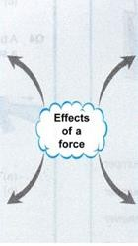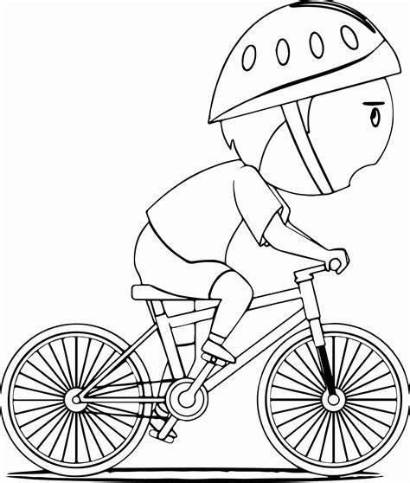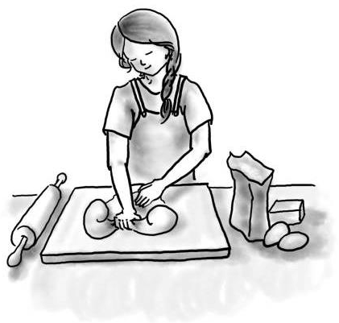Imagine that your team is playing a game of tug of war with another team. What should your team do to win the game?

All team members should use pull force to play and win tug of war for the team.

1. 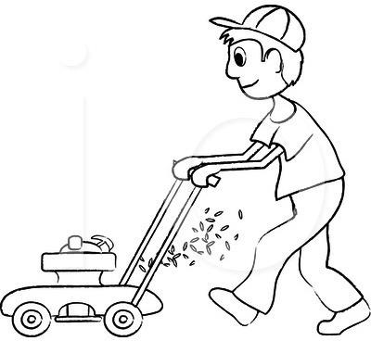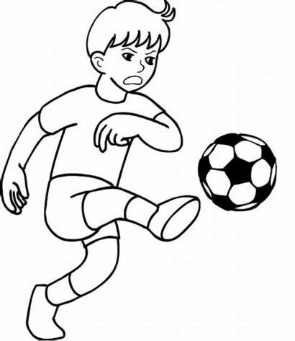**Identify and write the effect of force**